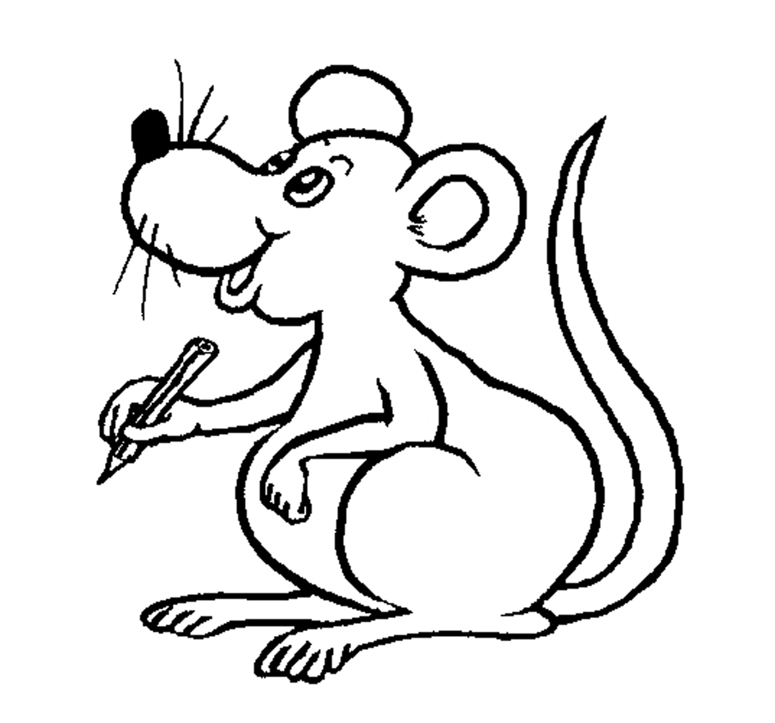©Bee Reading 2009

1st 42 Days of Jolly Phonics - Step-by-Step

Recommended pacing:
Kindergarten – 1 sound each day
Preschool/PreK/Early Childhood – 2-3 sounds per week

1) Do your introduction of the story line for today’s sound, embellishing as you wish
2) Show the picture for that sound (using the wall frieze, finger phonics book and/or big book)
3) Introduce and practice the motion for that sound
4) Sing the song for that sound – Jolly Jingles or Jolly Songs
5) Have your student Sound Book #1 already made, and teach them to find and 'read' today’s sound
6) Pass around the Sound Prop for the sound of the day- choose something for each child to say. For example, when you pass around the plastic snake, you could have them tell anything they know about a snake, or tell the name of another animal they know, or tell a color a snake could be - any color will do, etc.
Then, each following school day, continue to introduce the new sound (following steps 1-6) and review all previously introduced sounds in whatever way you'd like. Remember to use the student Sound Books every day, then send them home once you've completed each set of 6 sounds in the book.

