©Bee Reading 2009

Name_________________________

All About Aa

It’s an alphabet letter:
__ B C D E F G H I J K L M N
__ b c d e f g h i j k l m n
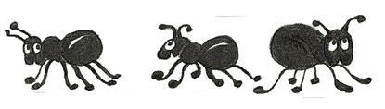
It has 2 sounds: ă + āi

It’s a word: A dog likes a bone.

Read these – listen for ă + āi


flăg căt trāin pāil

