Name_________________________

All About Ee

It’s an alphabet letter:
A B C D __ F G H I J K L M N
a b c d __ f g h i j k l m n
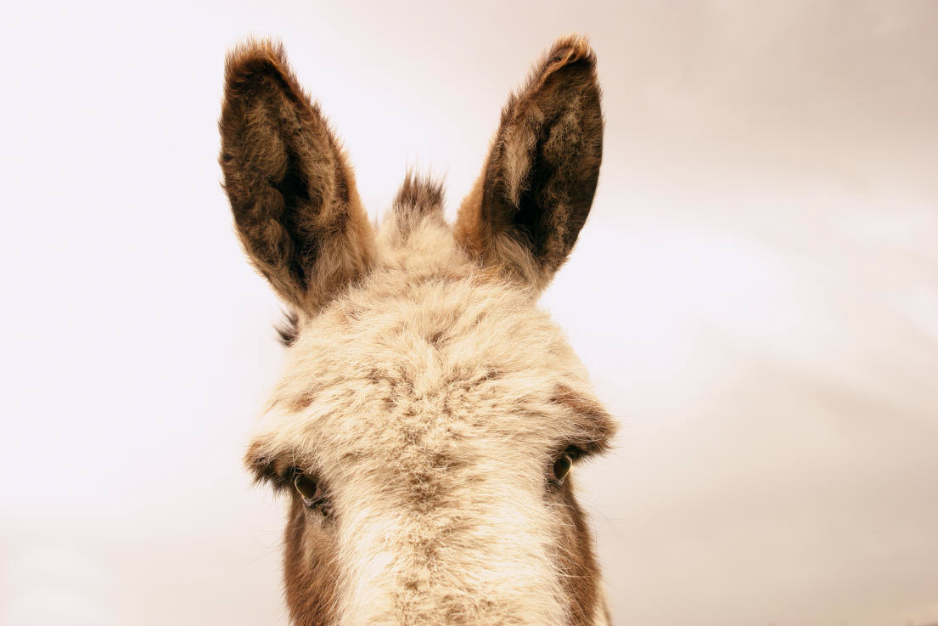

It has 2 sounds: ĕ + ēe

Read these – listen for ĕ +ēe

tĕn bĕd shēep trēe

