Name_________________________

All About Ii

It’s an alphabet letter:
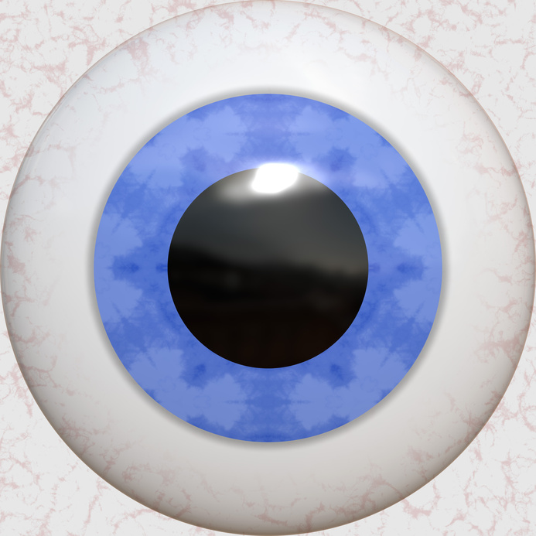
A B C D E F G H ___
a b c d e f g h ___
An eye is a
body part!

It’s a sound: ĭ + īe

It’s a word: I can see a cat.

Read these – listen for ĭ + īe


pĭg ĭgloo pīe tīe

