Name_________________________

All About Oo

It’s an alphabet letter:
A B C D E F G H I J K L M N _
a b c d e f g h i j k l m n _

It has 3 sounds, it is a word,
and it is a shape!
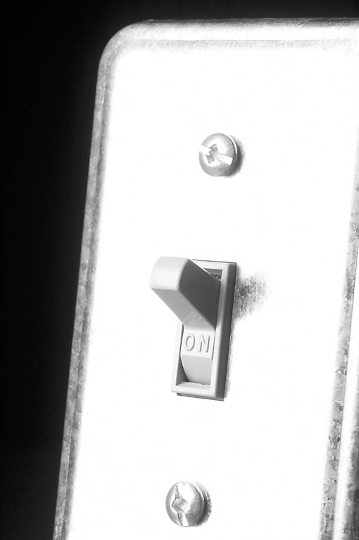
ōa
oh
ŏ
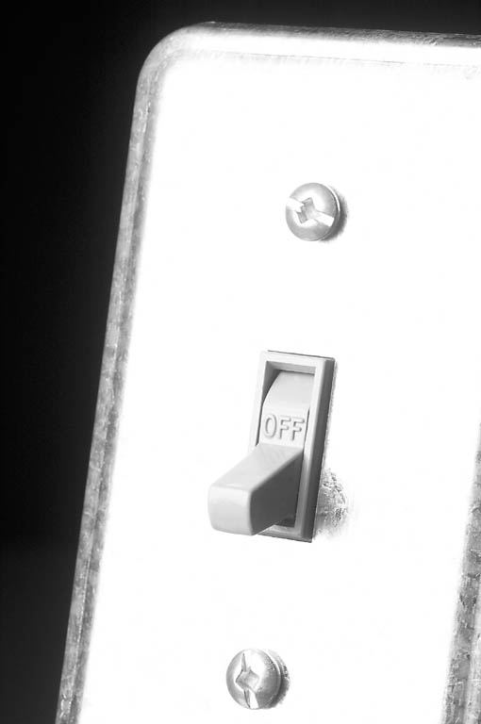
Two sounds for ŏ
as in on and off
Read these – listen for ŏ + ōa
Mŏm dŏts cōat flōat


