Jolly Phonics

Goal: Mastery of Groups 1-4 writing & spelling the sounds

*Please Note: We use
2 sounds for assessing short ŏ,
as heard in hotdog
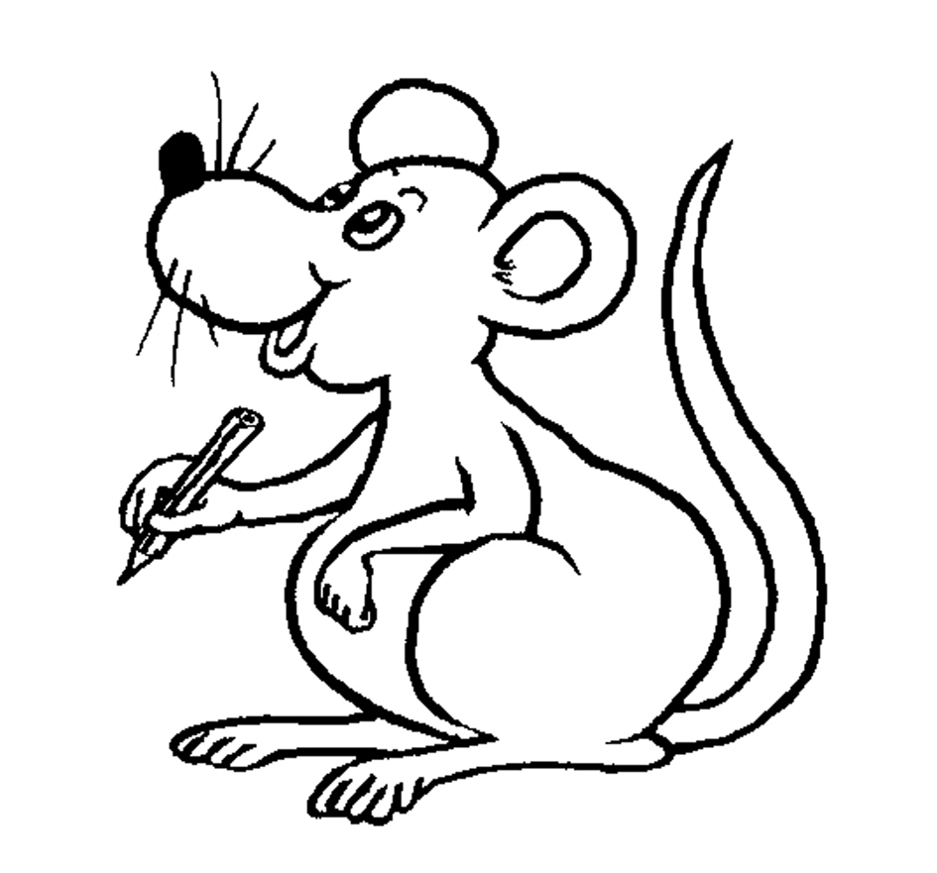
©Bee Reading 2009
Assessment
Spelling the Sounds
Part 1

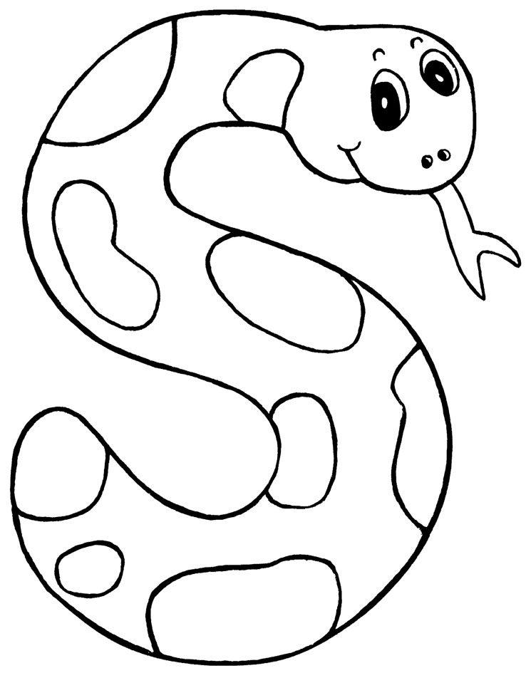
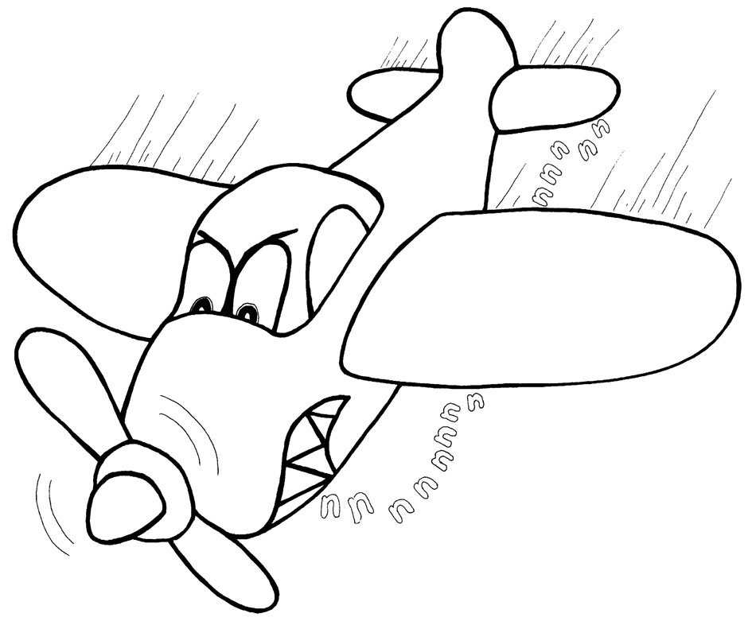
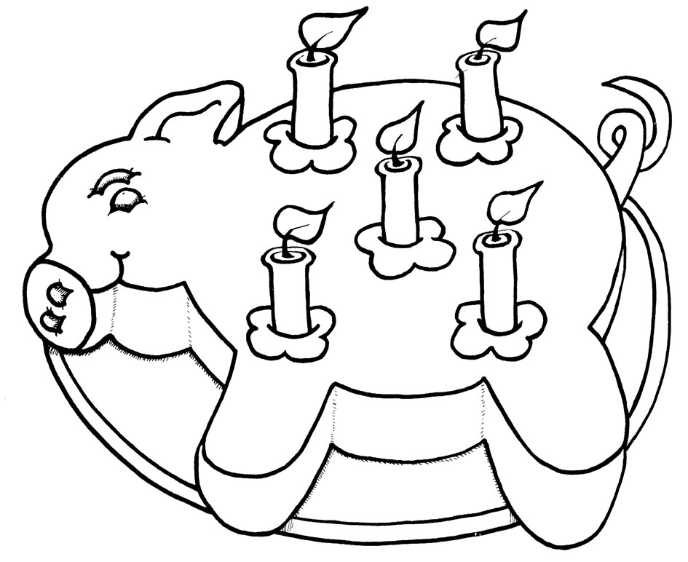
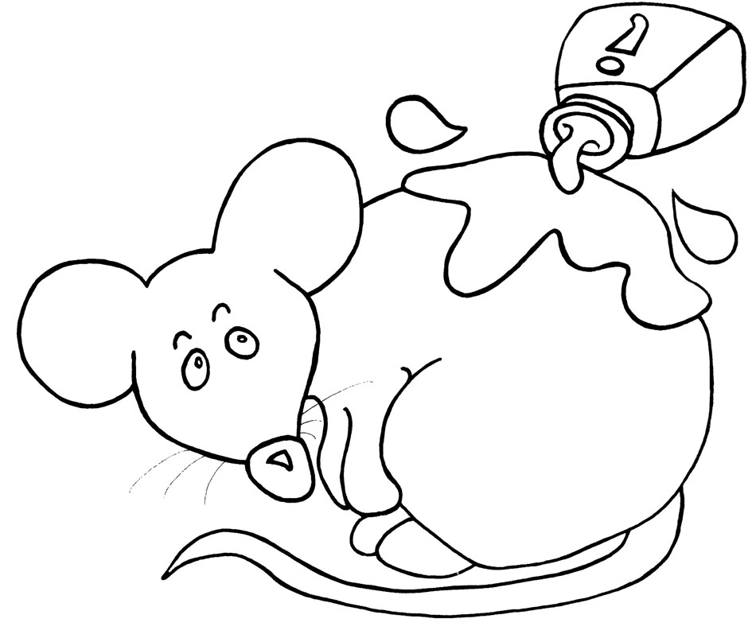
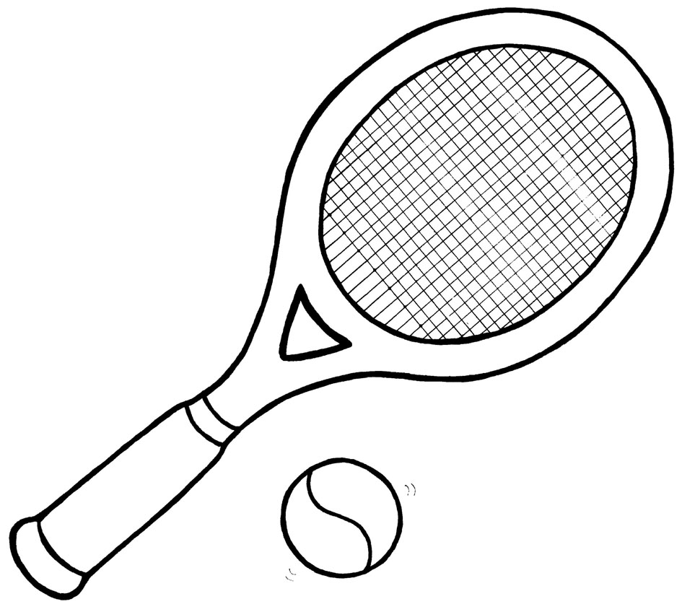
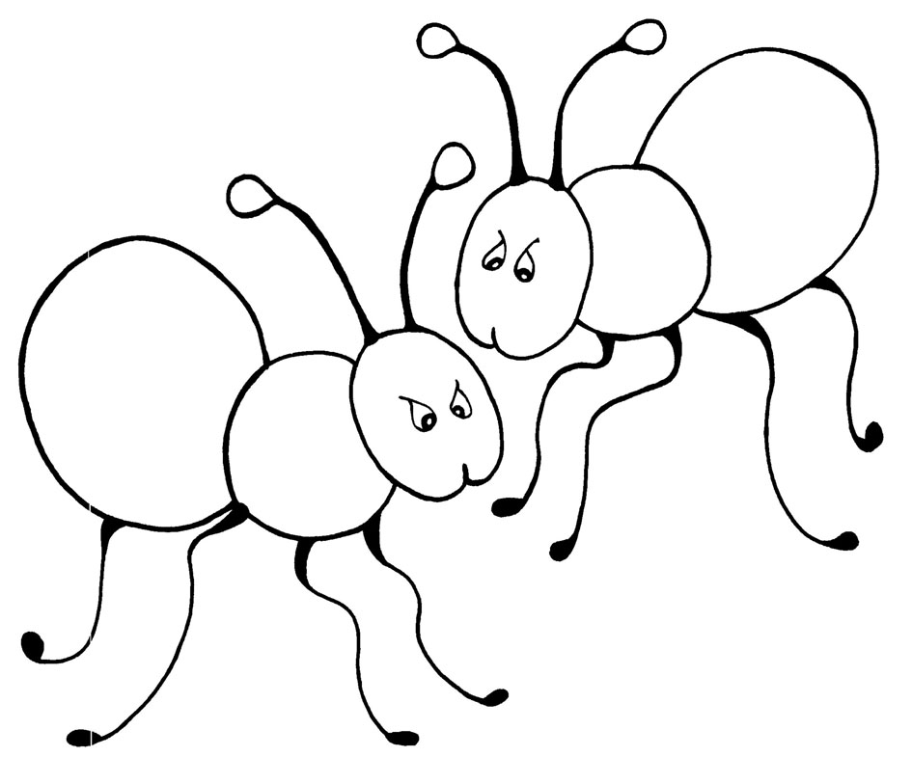
Group 1:

______ _________ ________ _________ _________ _________

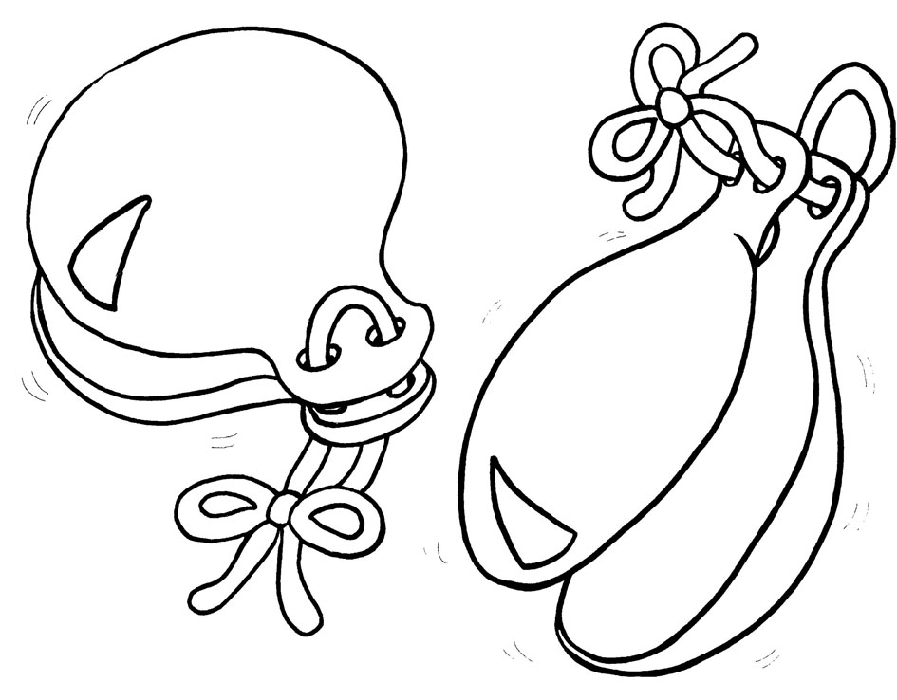
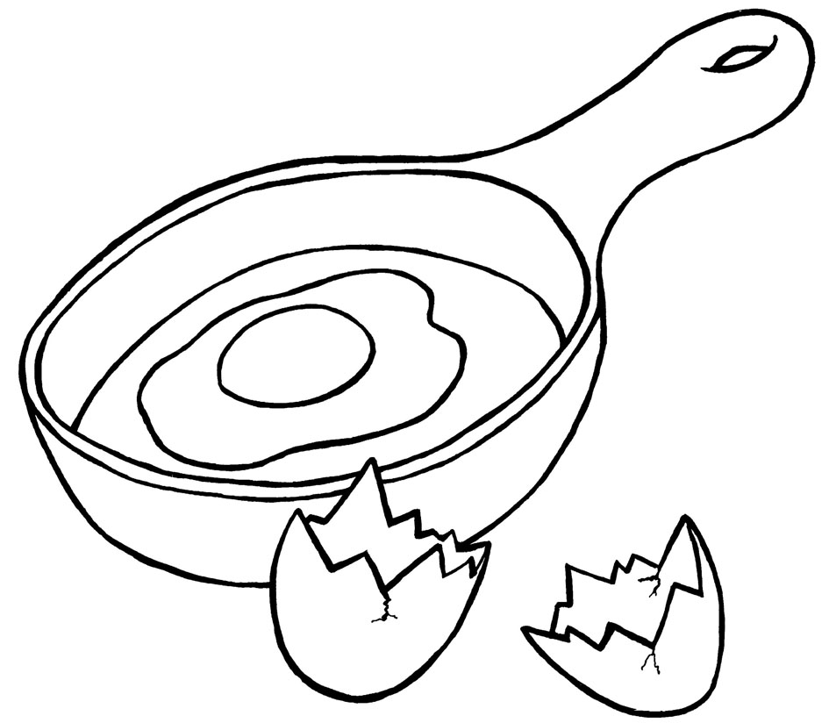
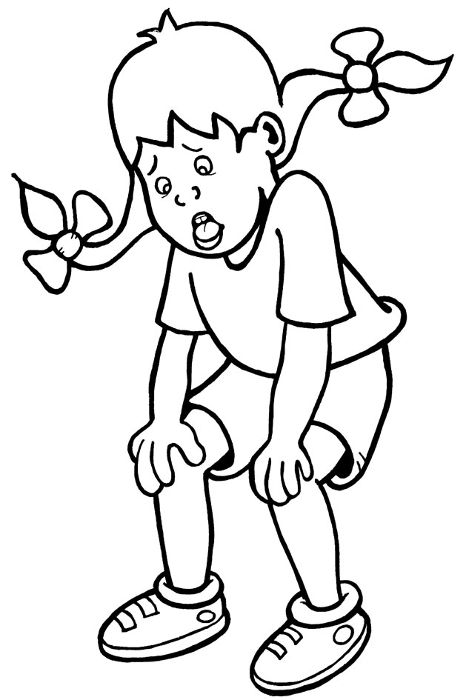
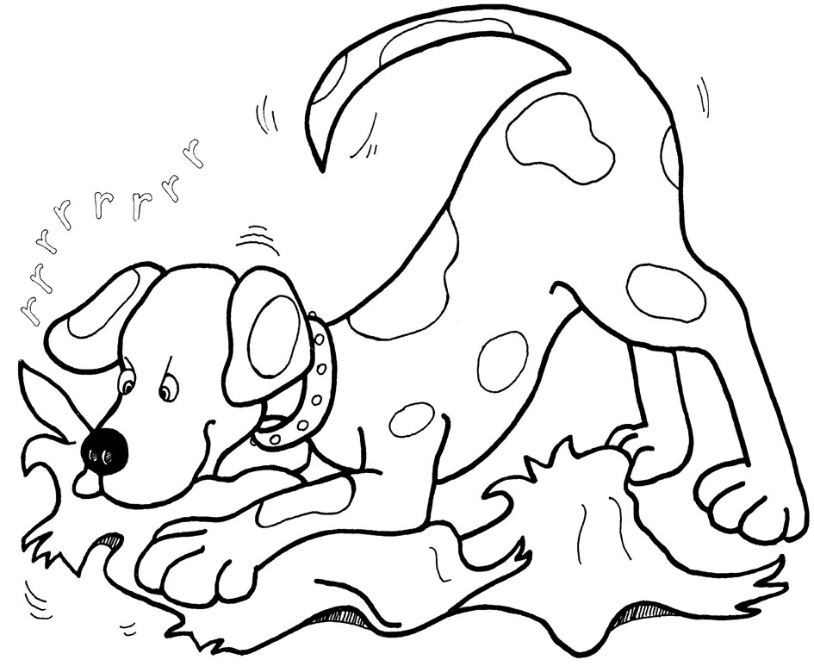

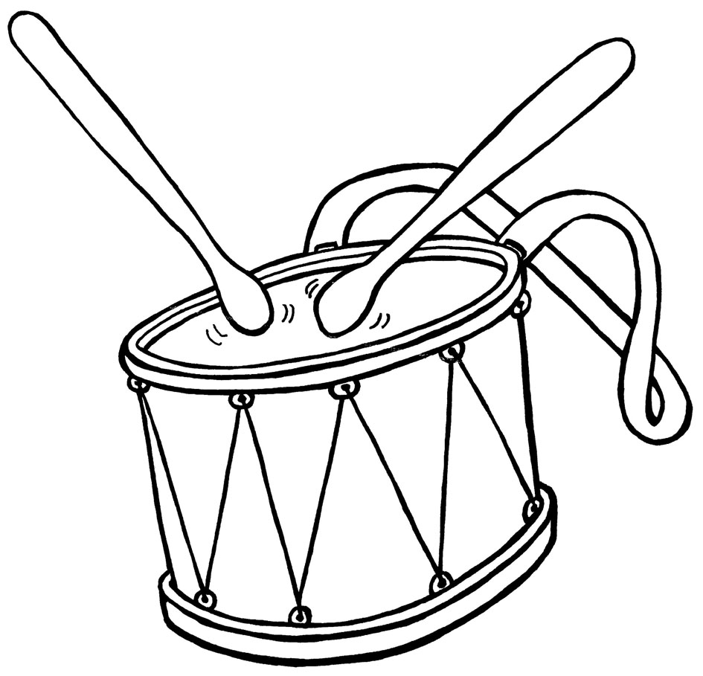
Group 2:

____ ____ ________ _______ __________ _________ _________

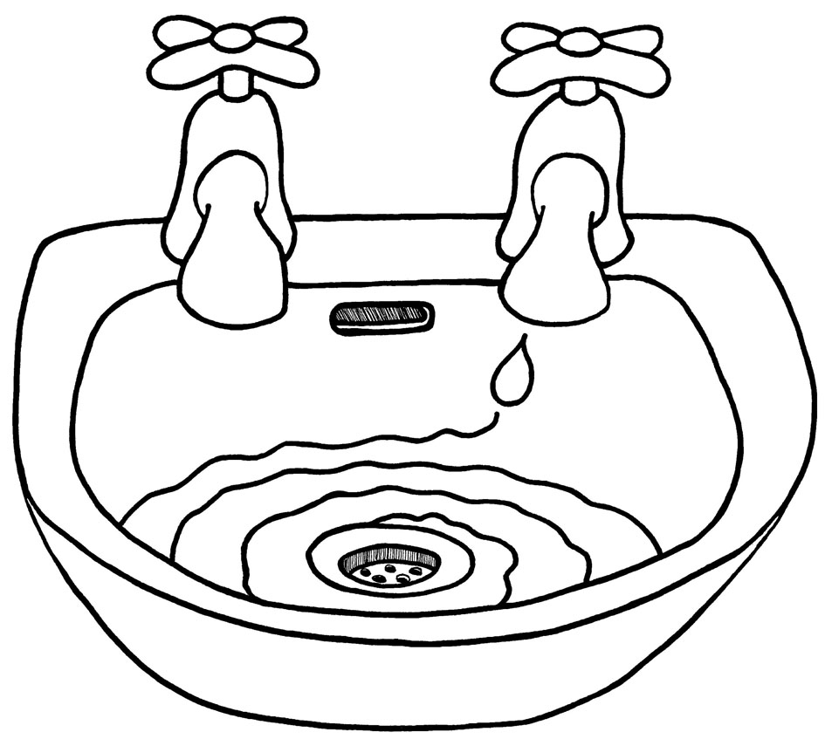
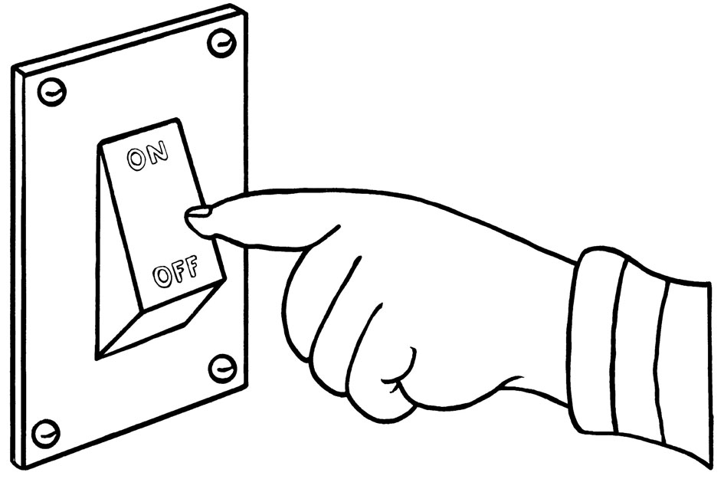
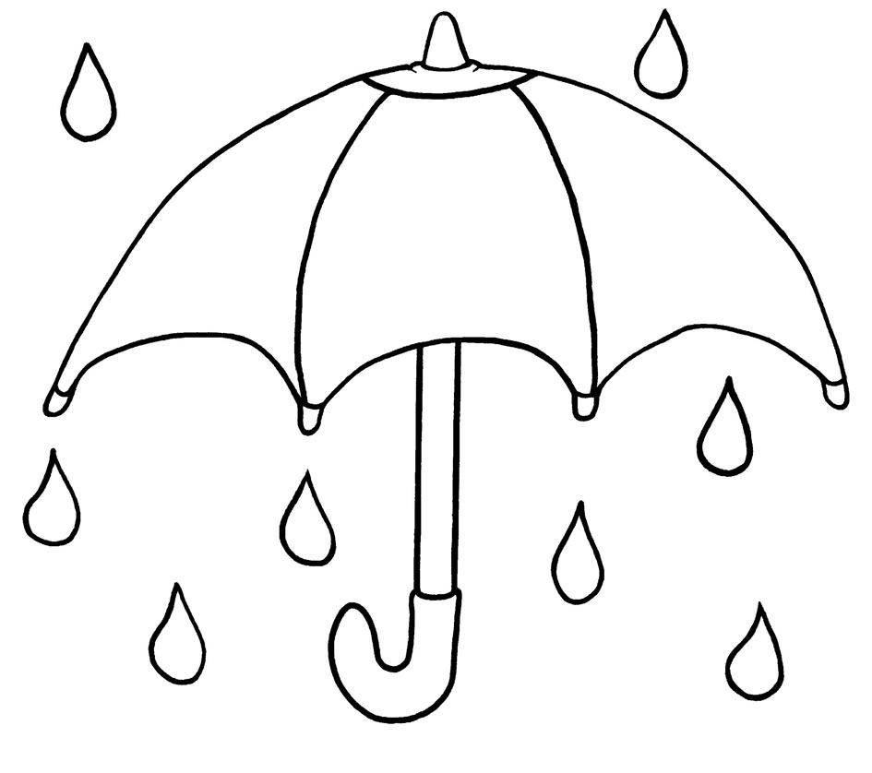
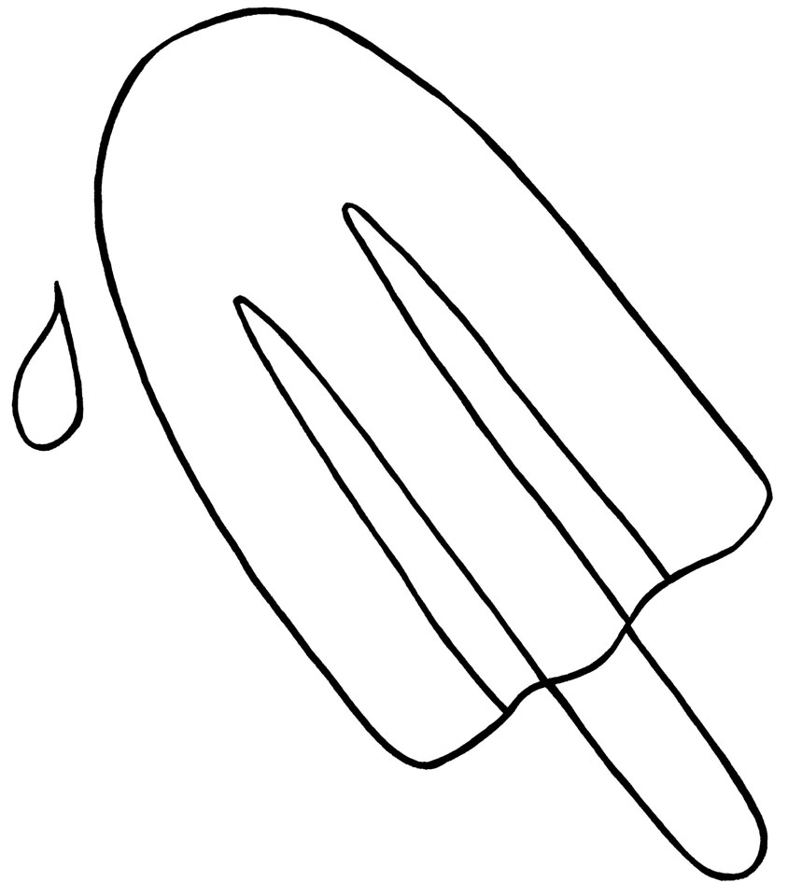
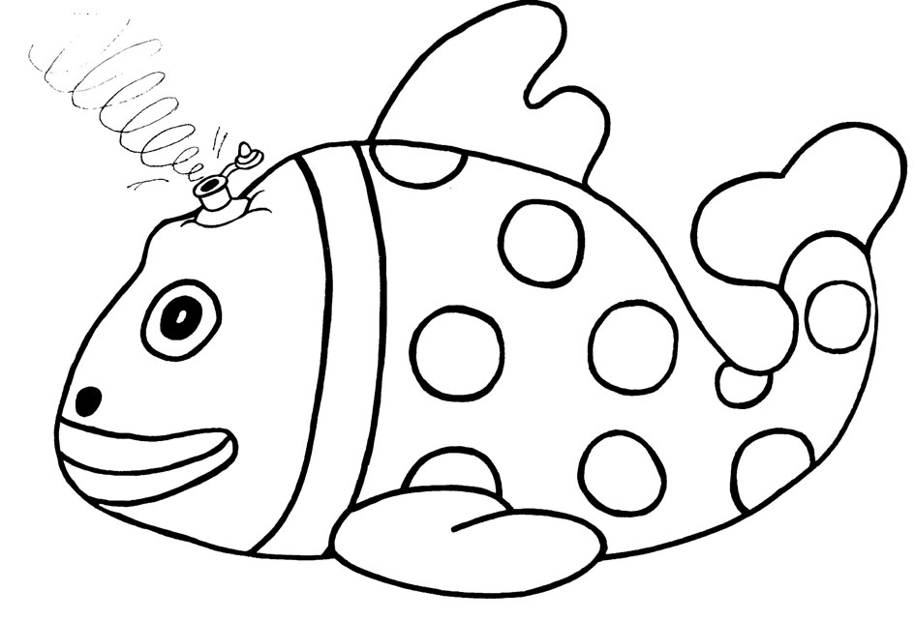
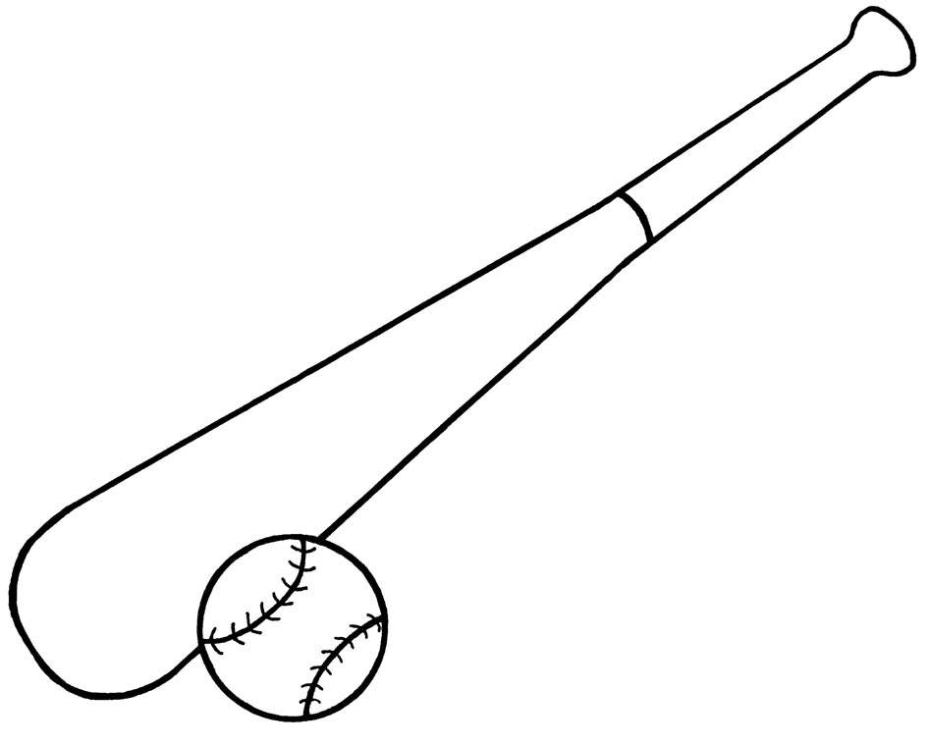
Group 3*:

_______ _____ ____ ________ _______ _________ ________

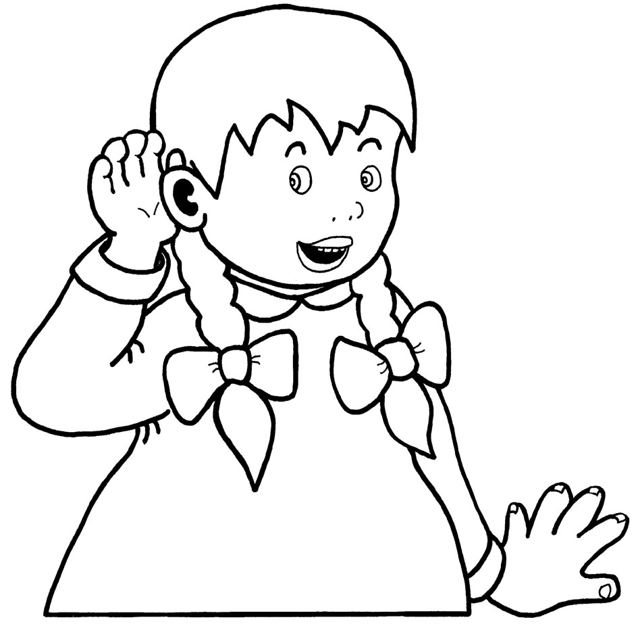
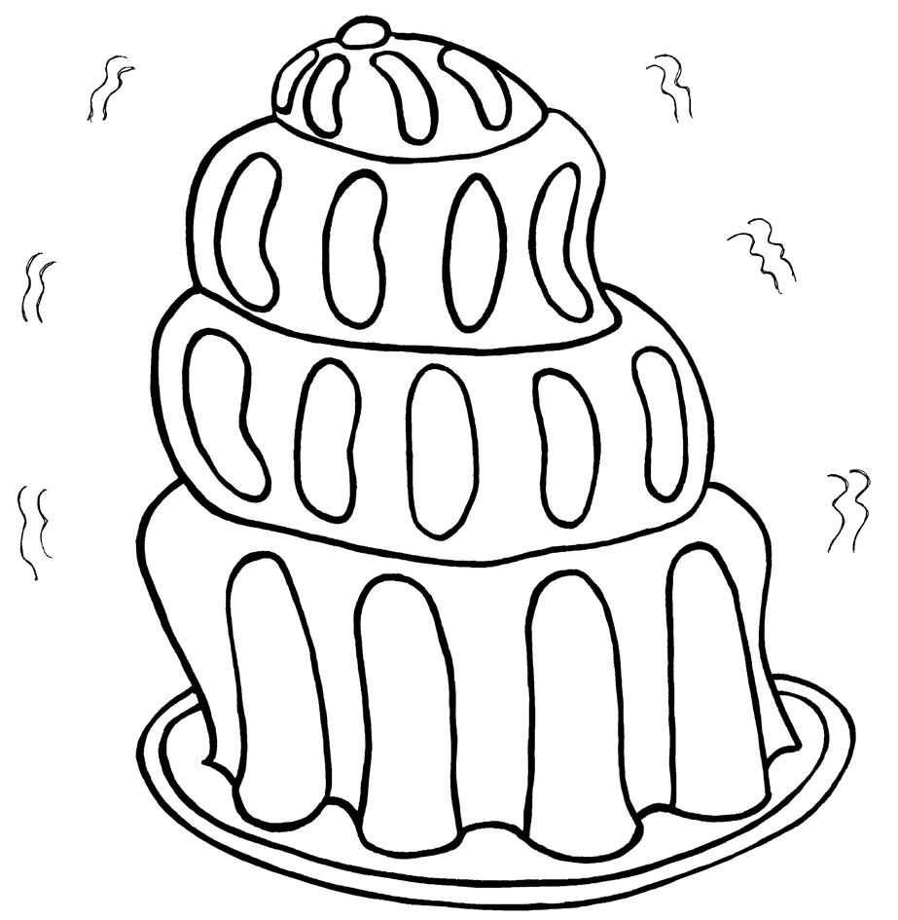
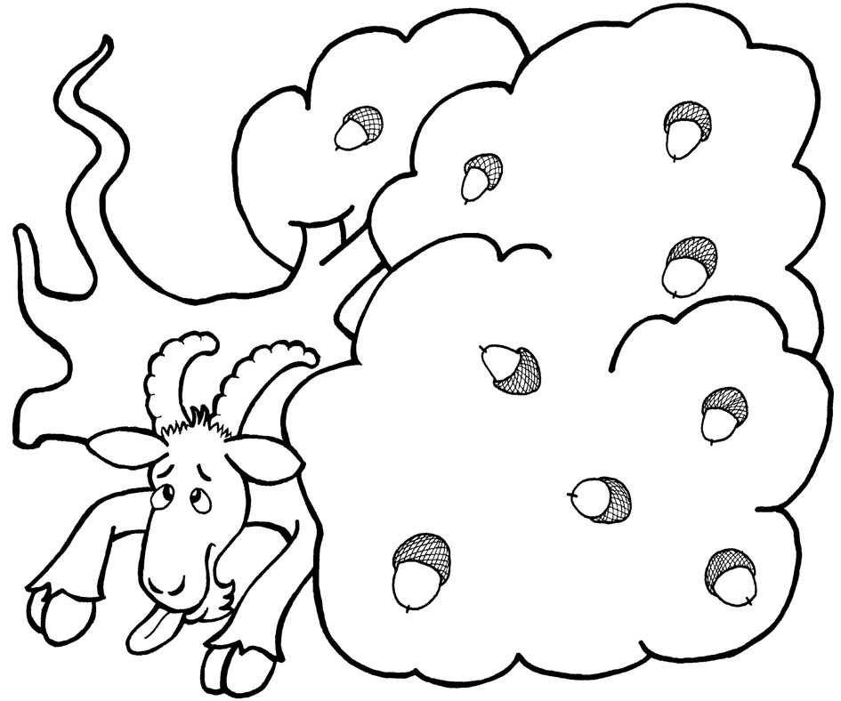
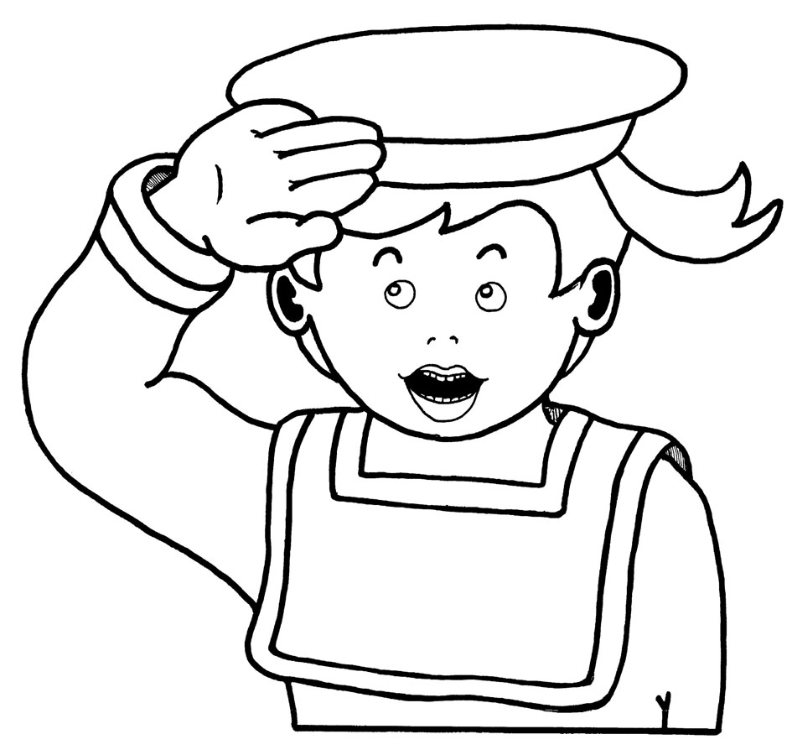
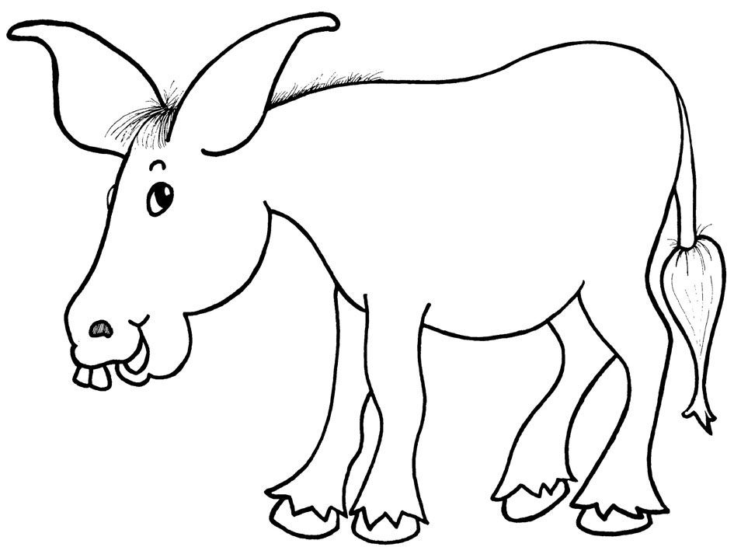
Group 4:

_______ _________ ________ _________ _____ ______

Date:______ Administered by_____ Spelling: ____/25 successfully spelled Percentage correct: ______
Date:______ Administered by_____ Spelling: ____/25 successfully spelled Percentage correct: ______
Date:______ Administered by_____ Spelling: ____/25 successfully spelled Percentage correct: ______
Date:______ Administered by_____ Spelling: ____/25 successfully spelled Percentage correct: ______

Jolly Phonics

Goal: Mastery of Groups 5-7 Writing & spelling the sounds

Assessment
©Bee Reading 2009
Spelling the Sounds
Part 2

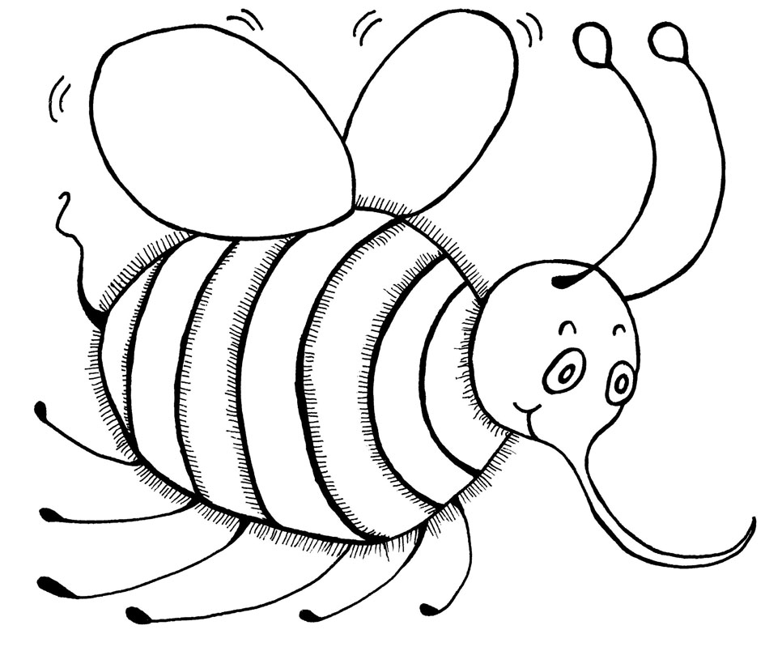
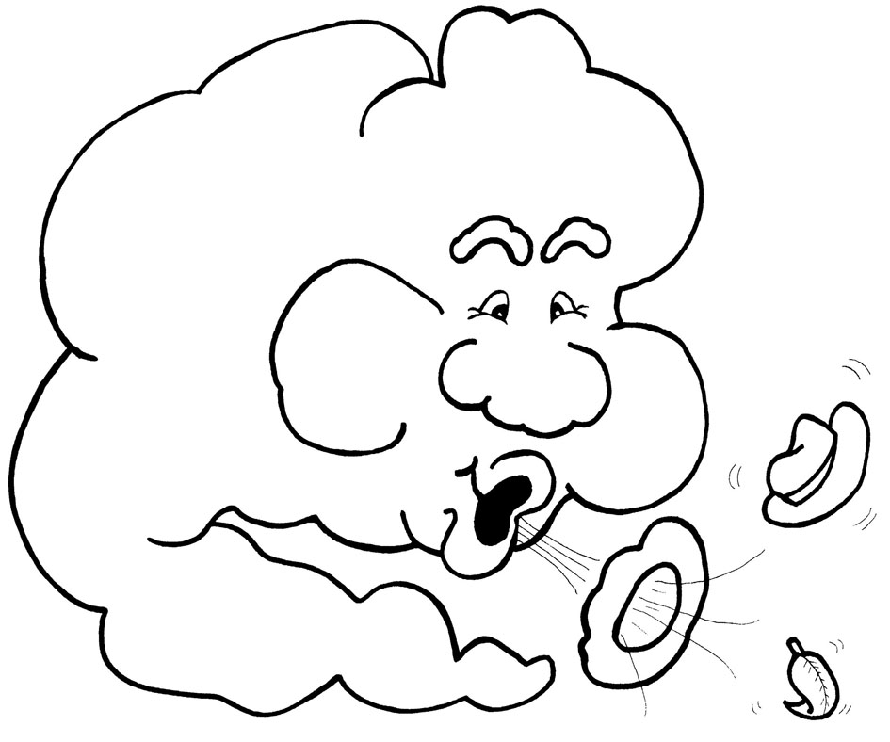
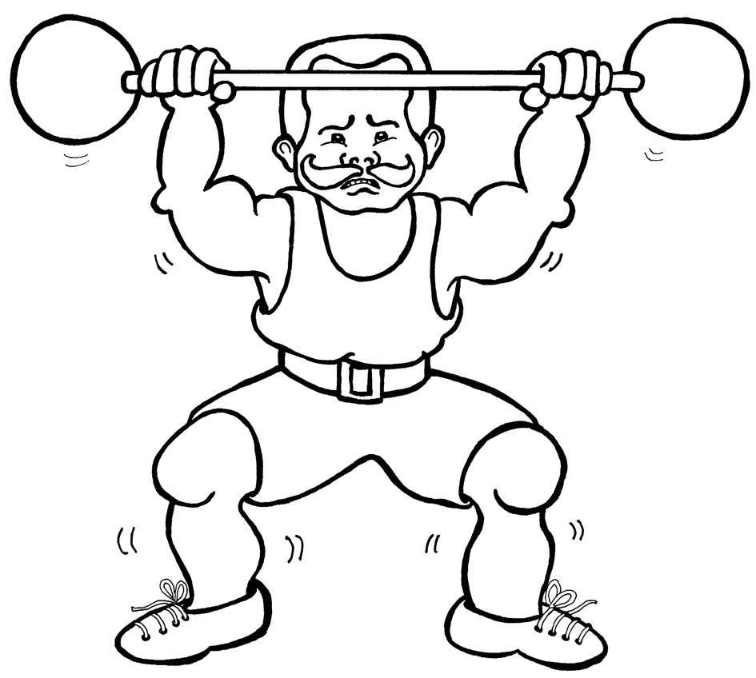
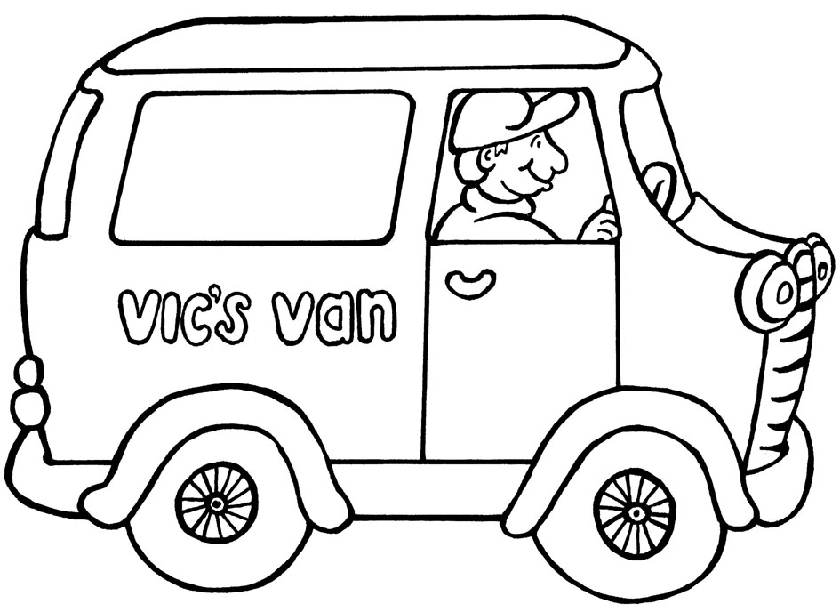
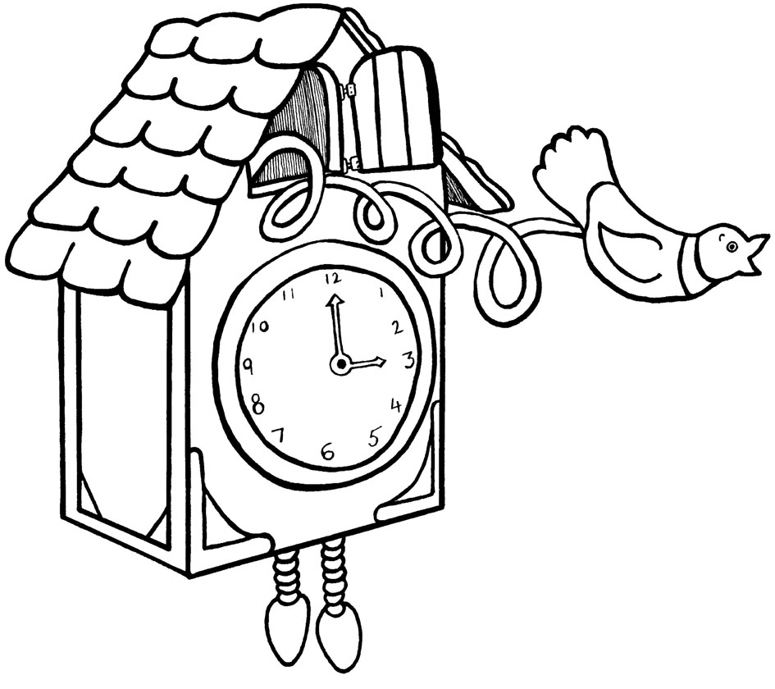
Group 5:

_______ _________ ________ _________ ______ ______

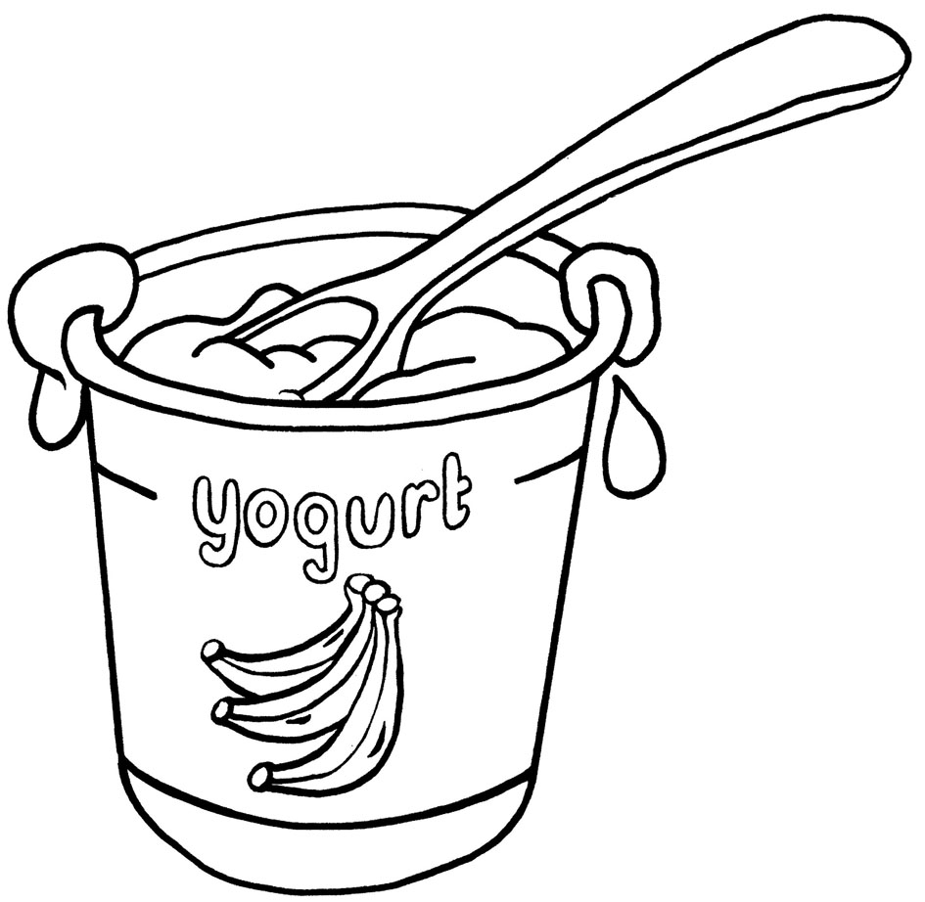
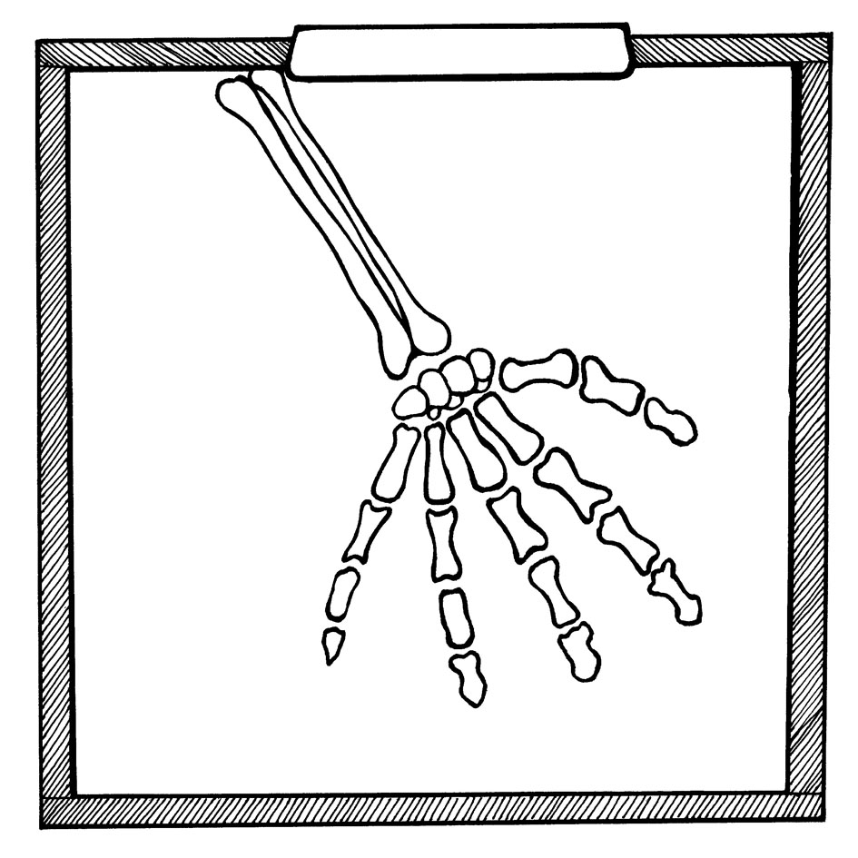
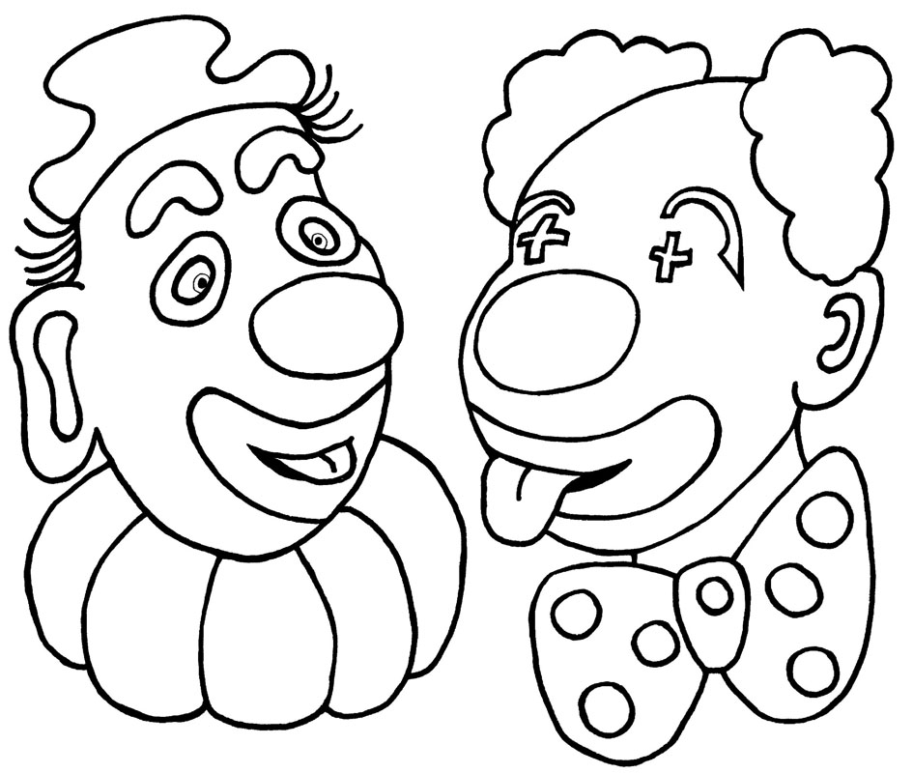
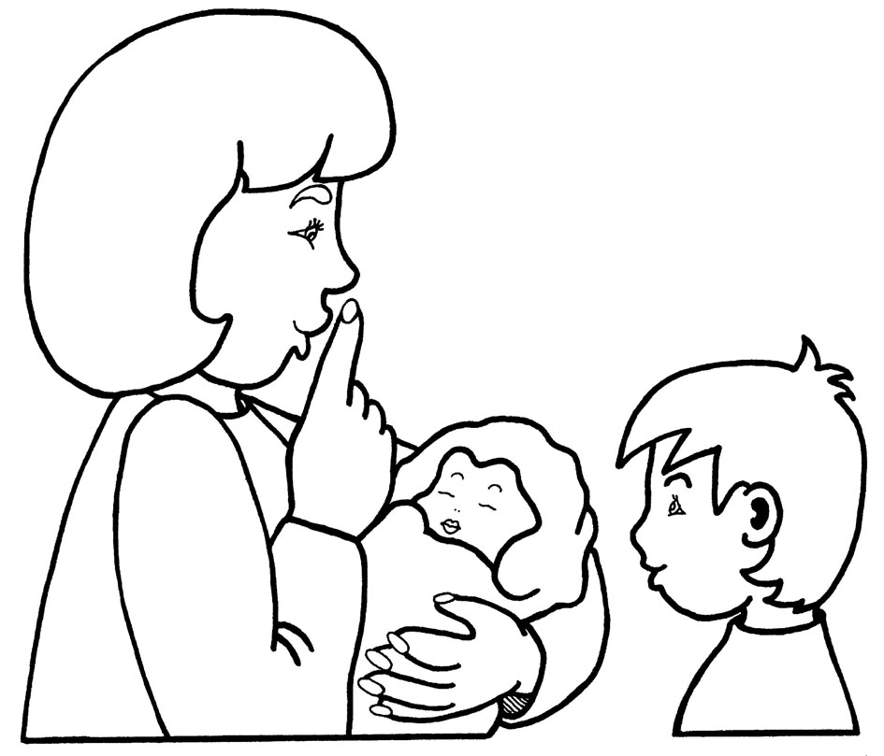
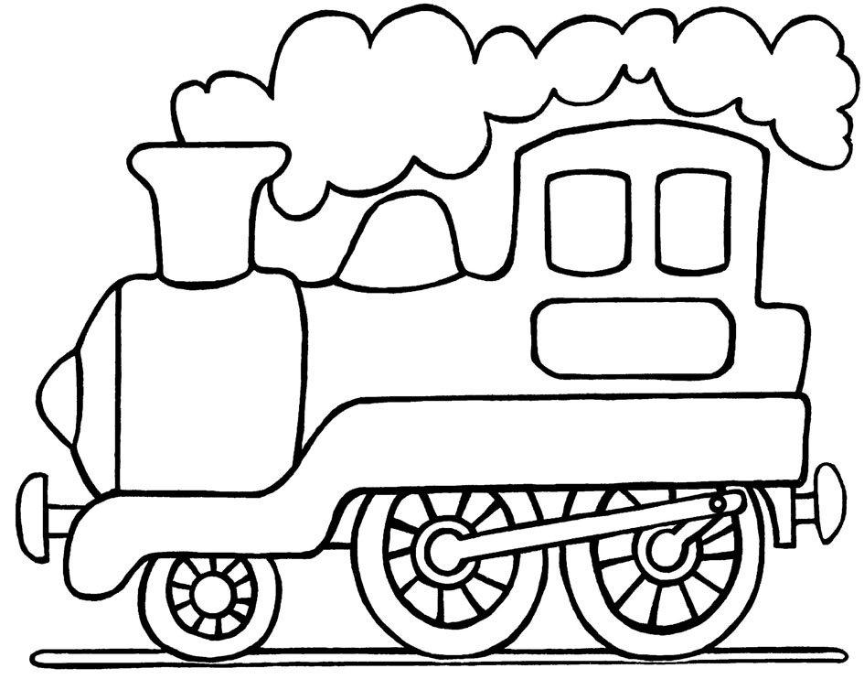
Group 6:

________ _________ ________ _________ _____ _____


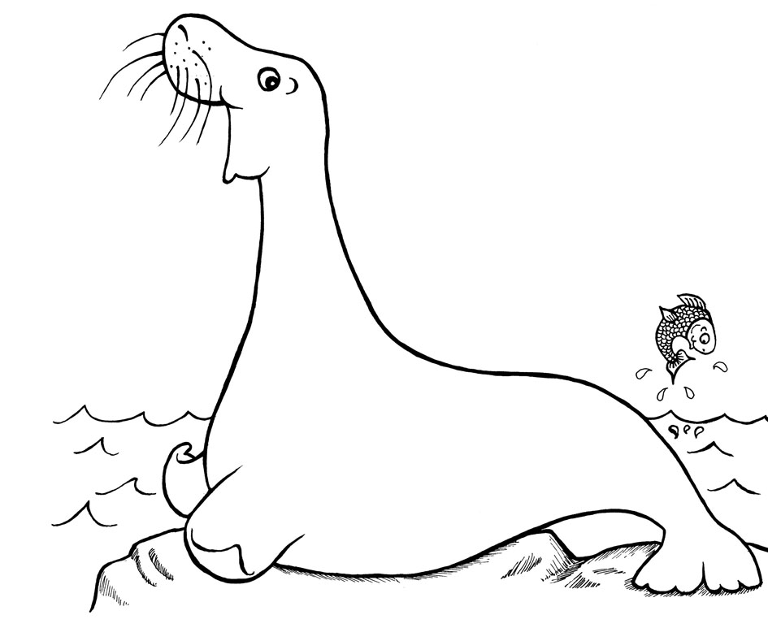
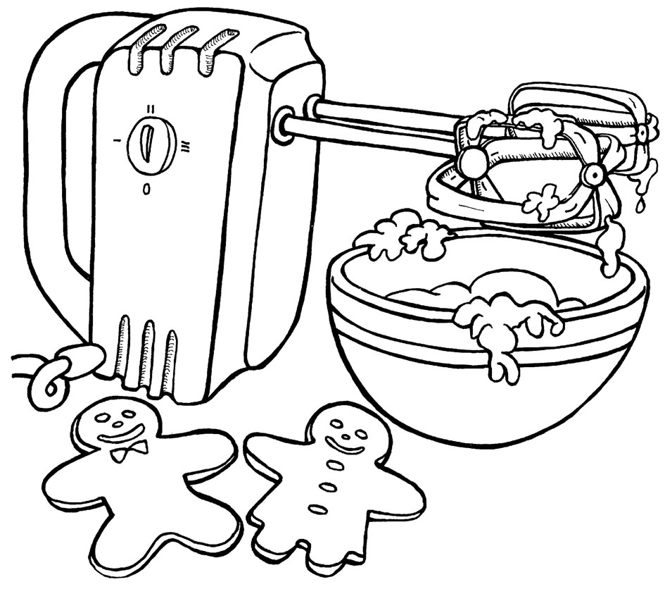
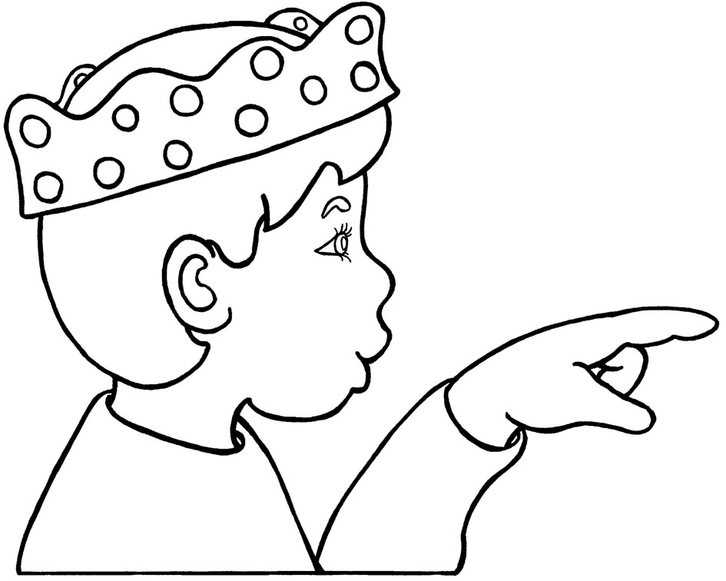

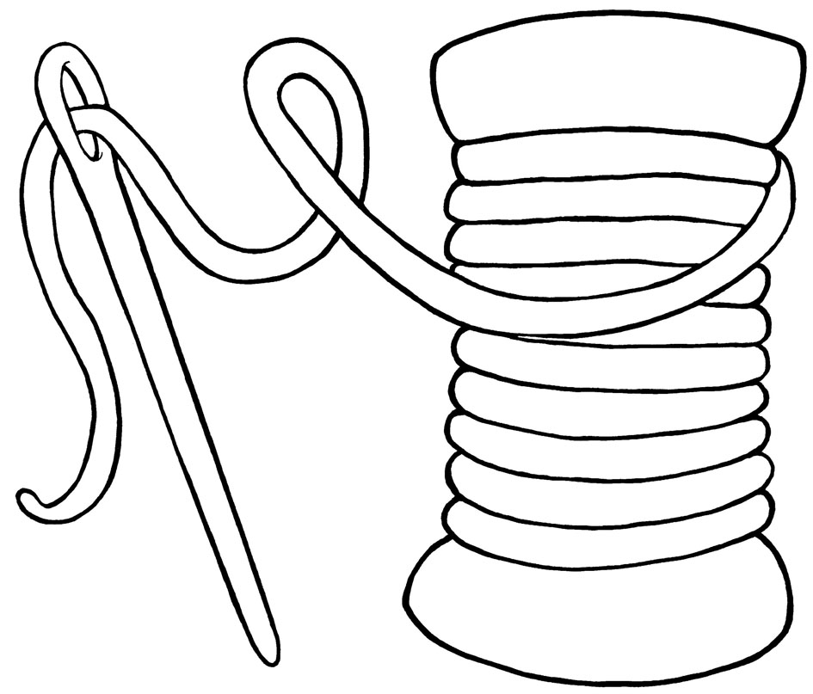
Group 7:
Date:______ Administered by_____ Spelling: ____/43* successfully spelled Percentage correct: _____
Date:______ Administered by_____ Spelling: ____/43* successfully spelled Percentage correct: _____
Date:______ Administered by_____ Spelling: ____/43* successfully spelled Percentage correct: _____
Date:______ Administered by_____ Spelling: ____/43* successfully spelled Percentage correct: _____
Date:______ Administered by_____ Spelling: ____/18 successfully spelled Percentage correct: ______
Date:______ Administered by_____ Spelling: ____/18 successfully spelled Percentage correct: ______
Date:______ Administered by_____ Spelling: ____/18 successfully spelled Percentage correct: ______
Date:______ Administered by_____ Spelling: ____/18 successfully spelled Percentage correct: ______
_________ _________ _________ _________ _________ _________
*PLEASE NOTE: We use 2 sounds for short ŏ, as heard in hotdog

