Student Name _________________________________________________

Dates assessed ______ ______ ______ ______ ______ ______
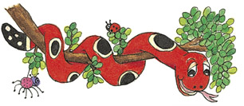

Jolly Phonics
Assessment #2
©Bee Reading 2009

Reading the Sounds

Goal: Mastery of reading all 43 sounds (Use 2 sounds for short ŏ, as heard in hotdog.)
Point to each sound and record if student can read the sound correctly.
Please Note: Be sure not to have the Jolly Phonics pictures for the student to look at.

Group 1: s a t i p n
Group 2: c k e h r m d

Group 3: g o o u l f b

Group 4: ai j oa ie ee or

Group 5: z w ng v oo oo

Group 6: y x ch sh th th
(voiced) (unvoiced)

Group 7: qu ou oi ue er ar

