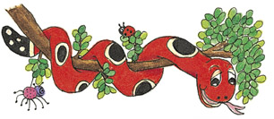
©Bee Reading 2009

My Jolly Phonics Book of
Short Vowels,
Long Vowels and
Double-Letter Sounds

Name_____________

